AIM:Design TM using simulator to perform addition of ‘aa’ and ‘aaa’

INPUT:

W=aa+aaaaa

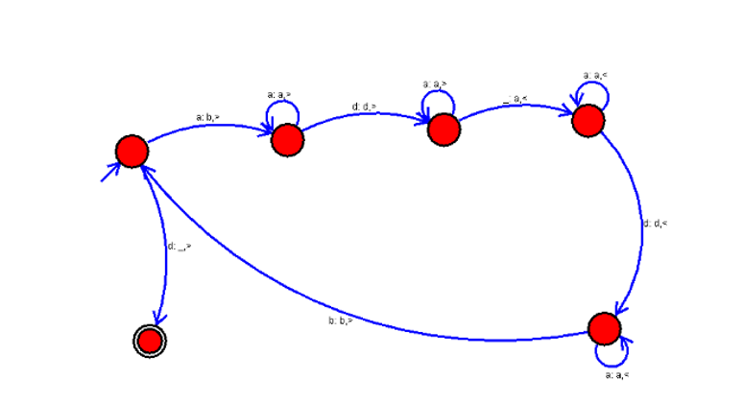

OUTPUT:

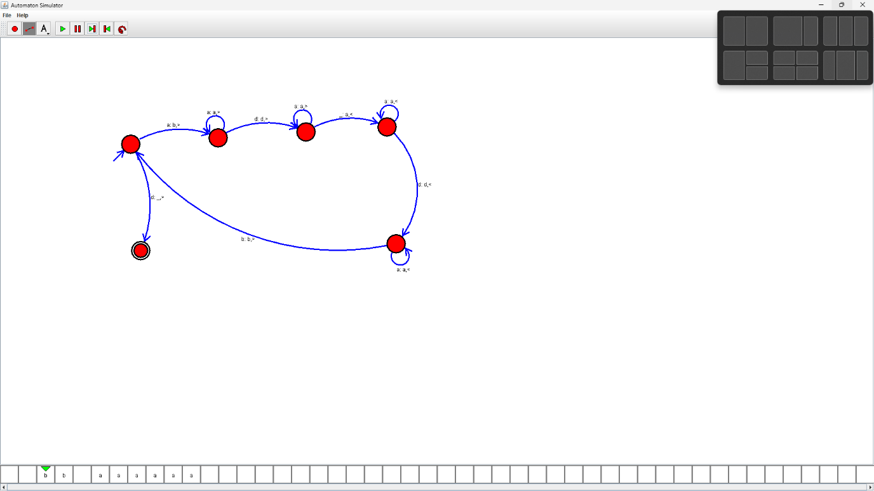

RESULTS:

We designedTM using to perform addition of ‘aa’ and ‘aaa’ by using autosim